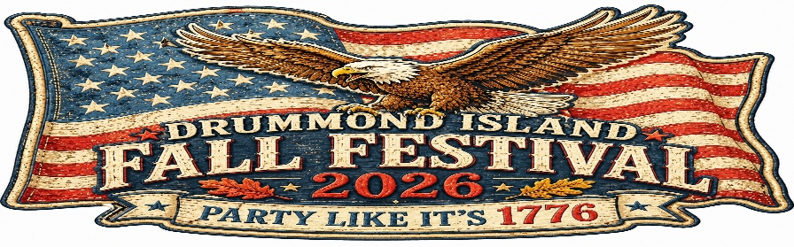
Fall Festival Artisans & Craft Show
Saturday, October 10th, 2026 11am – 5pm
DEADLINE FOR APPLICATION: October 3, 2026

Name:________________________________________________________________________

Street Address/P.O. Box:_________________________________________________________

City:_______________________________________ State:___________ Zip:______________

Phone:______________________ E-mail:___________________________________________

Description of Items: __________________________________________________

Please include photo(s) of your sale items with this form, by e-mail to: info@visitdrummondisland.com or by mail to: Drummond Island Tourism Association: P.O. Box 200, Drummond Island, MI 49726

Fee: $25.00 per 10’ x 10’ space
Number of spaces needed: _______________ (limit 2)
Total Fees Included ($25 x number of spaces): _________________
Will you require Internet access? (Cirlcle one) YES NO
NOTE: Starlink WiFi will be available for vendors. Password provided day of the show.

All spaces will be located inside a LARGE, HEATED TENT on the Festival Grounds. Your check or money order will be deposited upon acceptance. Once accepted, your fee is non-refundable.

Note: Failure to attend may result in loss of space in the future. NO vendors will be allowed to setup outside of our pre-arranged times. NO vendors will be allowed to leave early the day of the show.
I have read and agree to abide by the rules and regulations that apply to the 2026 Drummond Island Fall Festival. I understand that non-compliance with the rules and regulations may result in disqualification. (See attached vendor rules and regulations before signing!)

Signature_____________________________________ Date___________________________

